**Assignments on Generics:**

1. **import** java.util.HashSet;

**import** java.util.Scanner;

//creating employee class

**class** Employee{

**int** id;

String name;

**double** salary;

String department;

**public** Employee(**int** id,String name,**double** salary, String department) {

**this**.id=id;

**this**.name= name;

**this**.salary= salary;

**this**.department= department;

}

}

**public** **class** hello {

**public** **static** **void** main(String[] args)

{

HashSet<Employee> emp = **new** HashSet<Employee>();

//creating employees

Employee e1= **new** Employee(1, "Sawan Kundu", 11629.0, "Analyst");

Employee e2= **new** Employee(2, "Madhurika Dutta", 2000.20, "Analyst/ Software Engineer");

Employee e3= **new** Employee(3, "Anirban Dey", 26000.75, "Analyst Trainee");

//adding employess to Hashset

emp.add(e1);

emp.add(e2);

emp.add(e3);

**for** (Employee E: emp) {

System.***out***.println(E.id+" "+E.name+" "+E.salary+" "+E.department);

}

}

}

**Output:**

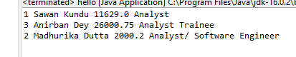

**import** java.util.HashMap;

**import** java.util.HashSet;

**import** java.util.Map;

**import** java.util.Scanner;

**public** **class** hello {

**public** **static** **void** main(String[] args)

{

Map<Integer, Double> s = **new** HashMap<Integer, Double>();

s.put(10,20.12);

s.put(11,21.73);

s.put(12,22.20);

s.put(13,23.10);

s.put(14,24.64);

s.put(15,25.17);

s.put(16,26.48);

s.put(17,27.39);

s.put(18,28.90);

s.put(19,29.55);

**for**(Map.Entry m:s.entrySet()){

System.***out***.println("int values: "+m.getKey()+" "+"double values: "+m.getValue());

}

}

}

**Output:**

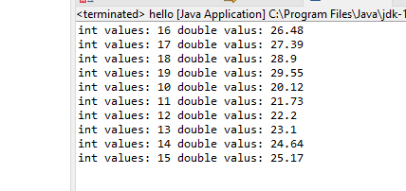

**3.**

**package** generics;

**import** java.util.ArrayList;

**import** java.util.Arrays;

**import** java.util.Collections;

**import** java.util.List;

**public** **class** GenericsMethod {

**public** **static** **final** <T> **void** swap (T[] a, **int** i, **int** j) {

T t = a[i];

a[i] = a[j];

a[j] = t;

}

**private** **static** **void** test() {

String [] a = {"Hello", "World"};

*swap*(a, 0, 1);

System.***out***.println("after exchange the position : "+Arrays.*toString*(a));

}

**public** **static** **void** main(String[] args)

{

*test*();

}

}

**Output:**

**g3.PNG**

**4.a**

**//Pair Clss**

**public** **class** Pair <K,V>{

K key;

V value;

**public** Pair(K i, V v) {

**this**.key = i;

**this**.value= v;

}

**public** K getKey() {

**return** key;

}

**public** V getValue() {

**return** value;

}

}

//Main class

**public** **class** hello {

**public** **static** **void** main(String[] args){

Pair<String, String> p = **new** Pair<String, String>("1", "Hello");

System.***out***.println(p.getKey()+" "+p.getValue());

Pair<String, String> p2 = **new** Pair<String, String>("2", "Hello1");

System.***out***.println(p2.getKey()+" "+p2.getValue());

Pair<String, String> p3 = **new** Pair<String, String>("3", "Hello2");

System.***out***.println(p3.getKey()+" "+p3.getValue());

}

}

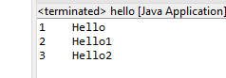**Output:**

**b.**

**//Pair Clss**

**public** **class** Pair <K,V>{

K key;

V value;

**public** Pair(K i, V v) {

**this**.key = i;

**this**.value= v;

}

**public** K getKey() {

**return** key;

}

**public** V getValue() {

**return** value;

}

}

//Main class

**public** **class** hello {

**public** **static** **void** main(String[] args){

Pair<String, java.util.Date> p = **new** Pair<String,java.util.Date >("Today is: ", **new** java.util.Date());

System.***out***.println(p.getKey()+" "+p.getValue());

}

}

**Output:**

**g4b.PNG**